Penrose Pattern Generator Documentation

Many pattern generators use the deflation method to generate the pattern. I wanted one, where the tiles are placed one after another like you would do at home…

**The Foundations**

This Pattern Generator uses the P2 tileing, the **Darts** and **Kites**.

Kite 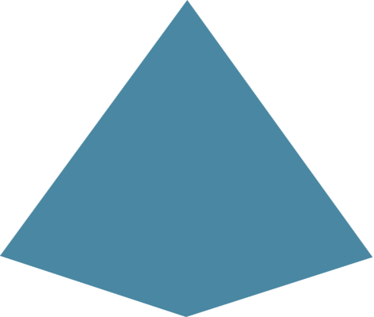 Dart 

These tiles have some placement rules which must be followed for a continuous pattern to achieve.

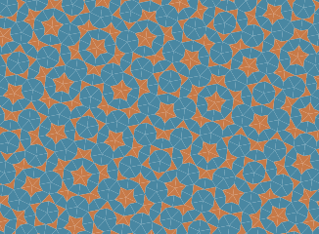

*For deeper and a more scientific explanation of rules please read the documentation on the following link:* <https://physics.princeton.edu//~steinh/growthQC.pdf>

*or the same document in my GitHub Repo:* // todo paste link

Before I start, please consider the next picture. These are the seven possible figures how the tiles can be attached to each other. I call it **vertexRule**.

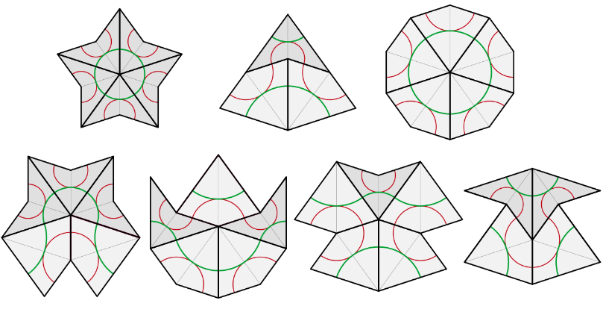

*Source: Wikipedia/Penrose tiling*

Ok, now. How the logic works? Each Tile has four **points** A,B,C,D and each point is attached to a **Dot** (red dots on the picture below). Every Dot has an occupation of tiles and points which 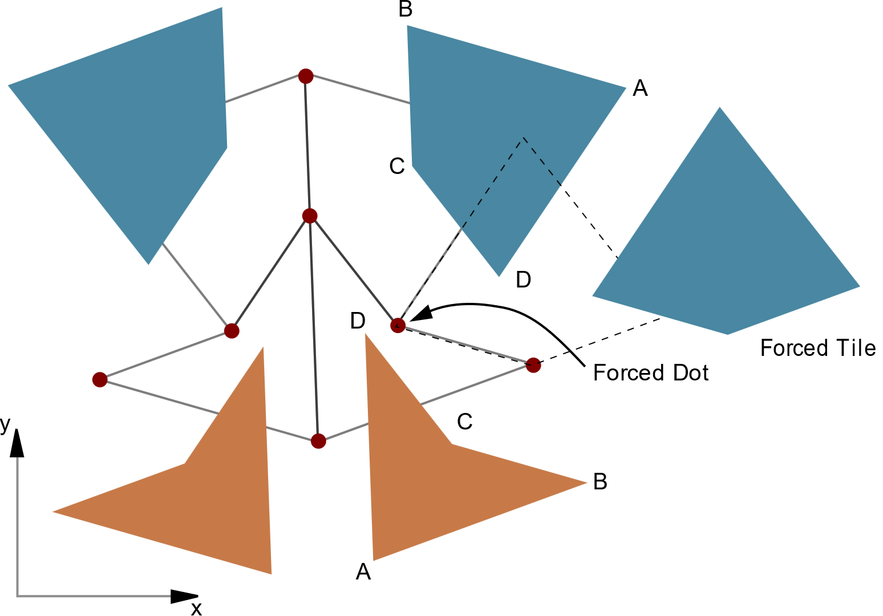encloses the dot.

There are just the seven possibilities how to attach tiles to each other and that’s it, why comes most of the time to a constellation where tiles are forced which one and how should be attached to a Dot.

Figure 1

Because of this, there are dots, which are **restricted** / forced and **open**. Open dots are all dots, where can be attached a tile (i.e. occupation is lower than 360 degree). With other words, open dots are all the dots on the edge of the whole pattern and yes, restricted dots are open dots too.

Now we must always attach tiles to restricted dots first, till there are no more left. Until that point, we have no other choice how to place the tiles. We are forced to place it after rules. When there are no more restricted dots, just open ones, we can choose **randomly** witch tile and where to place…

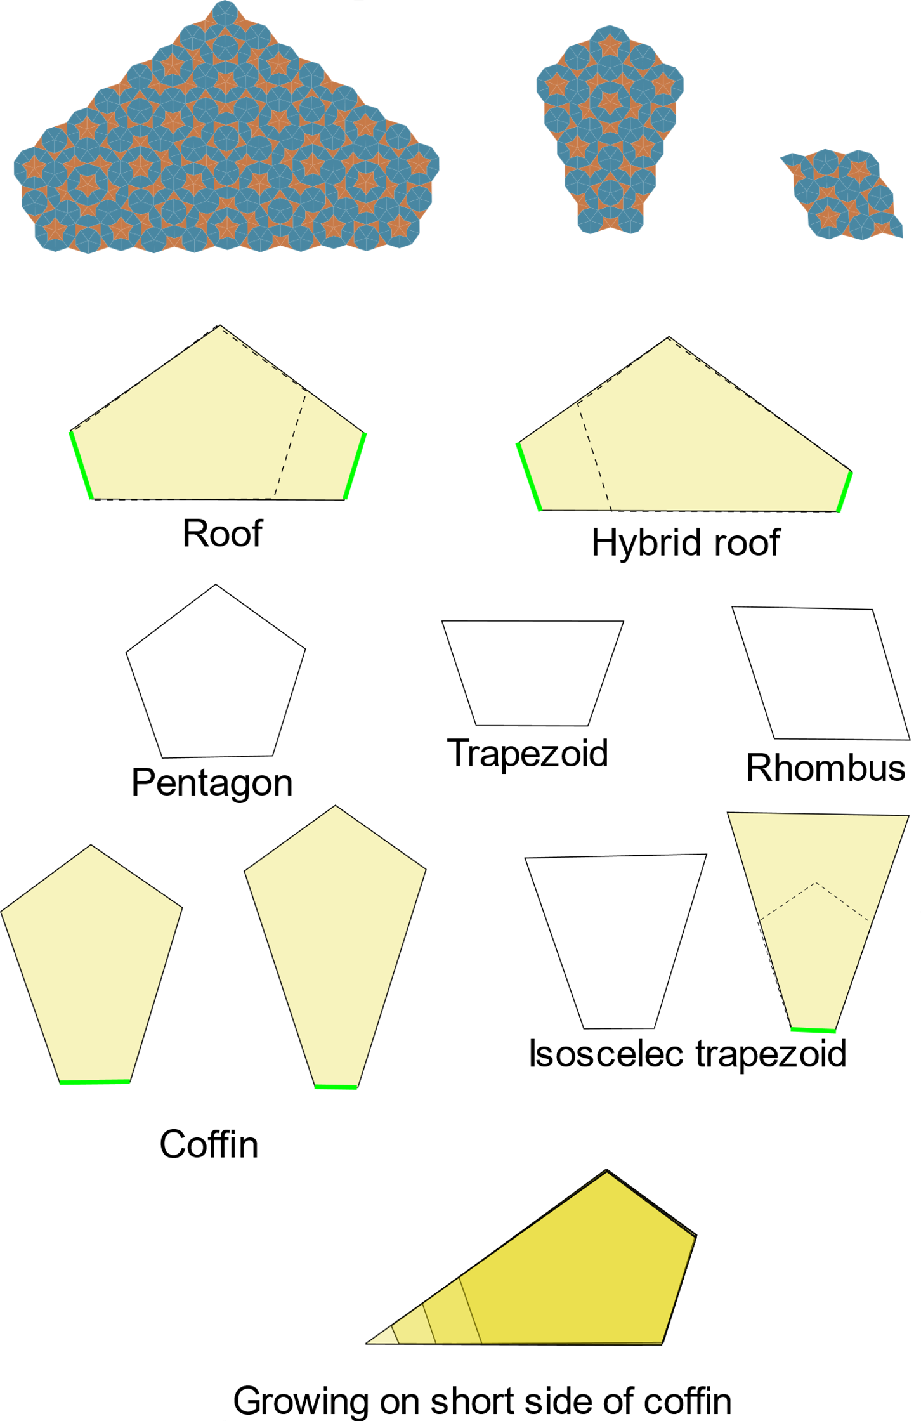No, that’s not really true, because there is another rule.

I call it **verticesRule.**

When we generate a pattern till no more restricted dots are left, we become some geometrical shapes (dead surfaces).

To these shapes it’s allowed to place a tile randomly, except on the shortest side of the coffin shapes and all other shapes, where the shortest side of the coffin is on the edge of the shape (yellow shapes). Aua, that sentence hurts.

Shortly, no random placement on the green lines.

On these sides we are forced to place a tile so, that the next shape must be a coffin too (see on the bottom of the picture). On other sides we can randomly place a tile.

There is one more thing left to know about. The worm.

The worm is a “line” of tiles which connects the shapes together. Why it’s important? Because of the **verticeRule** from above. When we 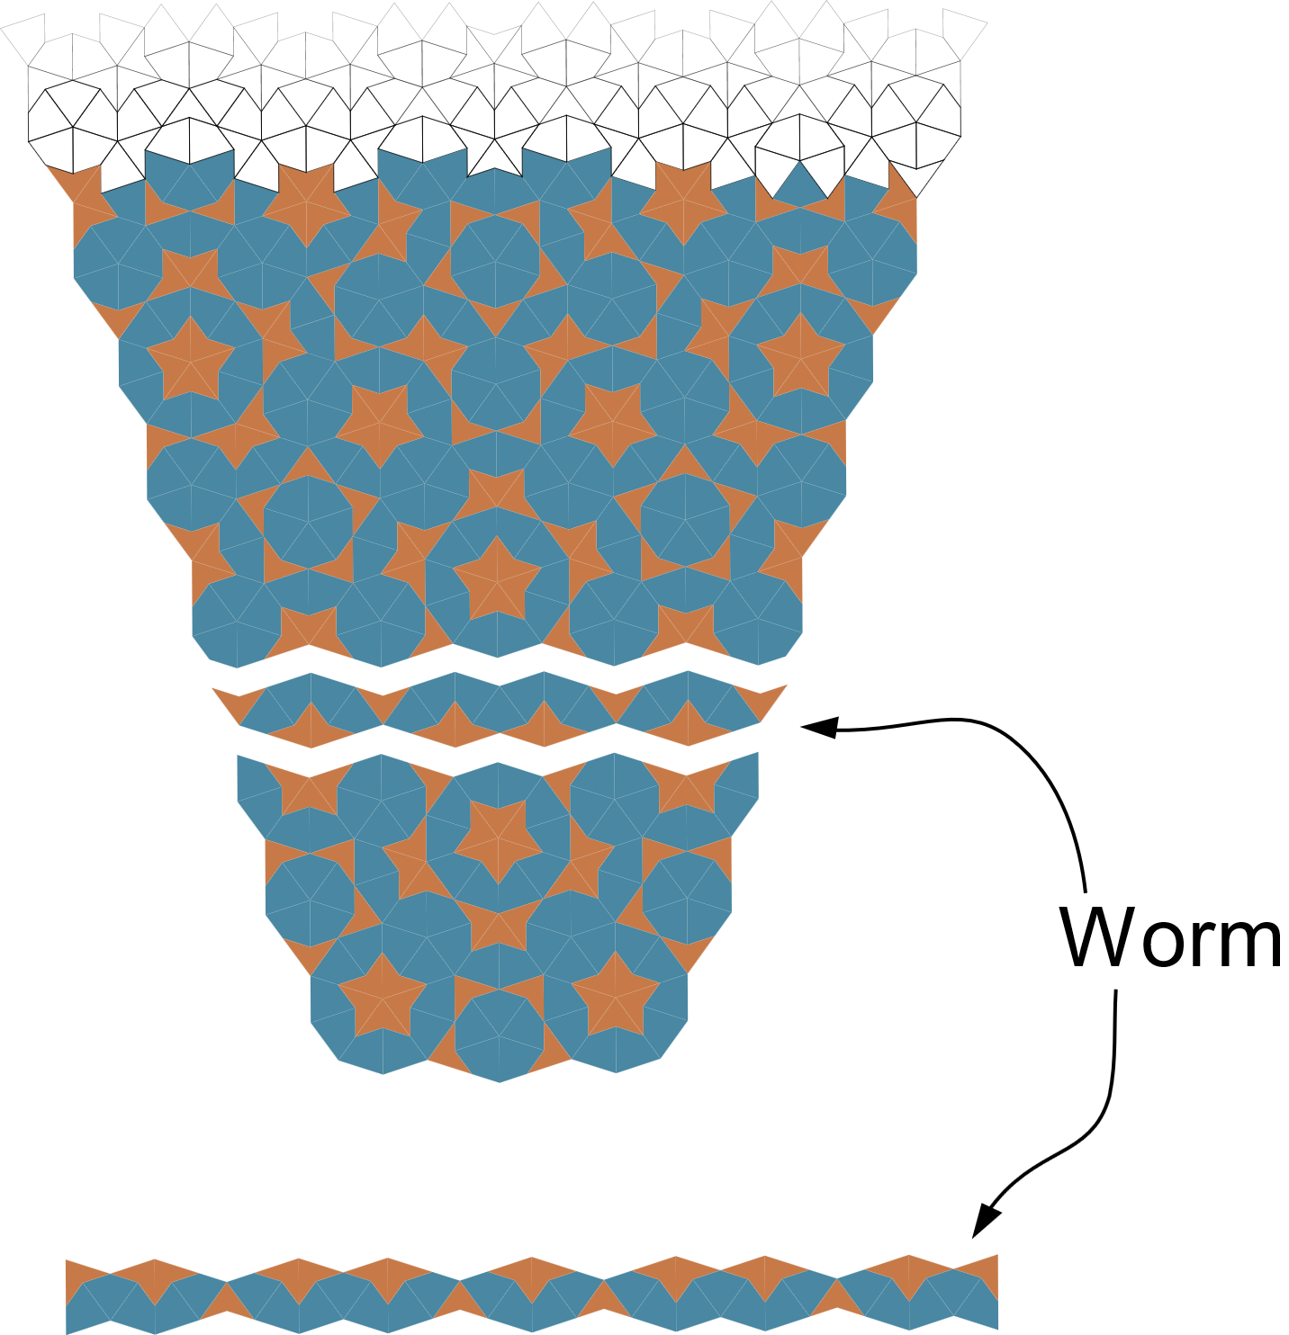want place a tile on the “green line” of the coffin shapes, this worm placement would decide which tile on which place must be placed.

Figure 2

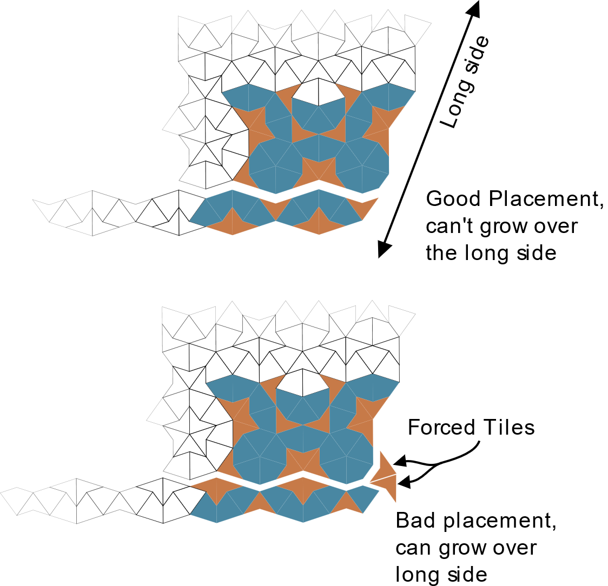Like I wrote before, the growing on the short side of coffin must be made so, that the next shape is a coffin shape. Better said, for the growth it is not allowed growing over the long sides (see pictures). When the worm is flipped / wrong placed, the Dot on the „**corner**“ would be restricted (forced) dot and the growing would be go over the long side.

Figure 3

Then happens anywhere later in the pattern an placement error, which don‘t follow the rules.

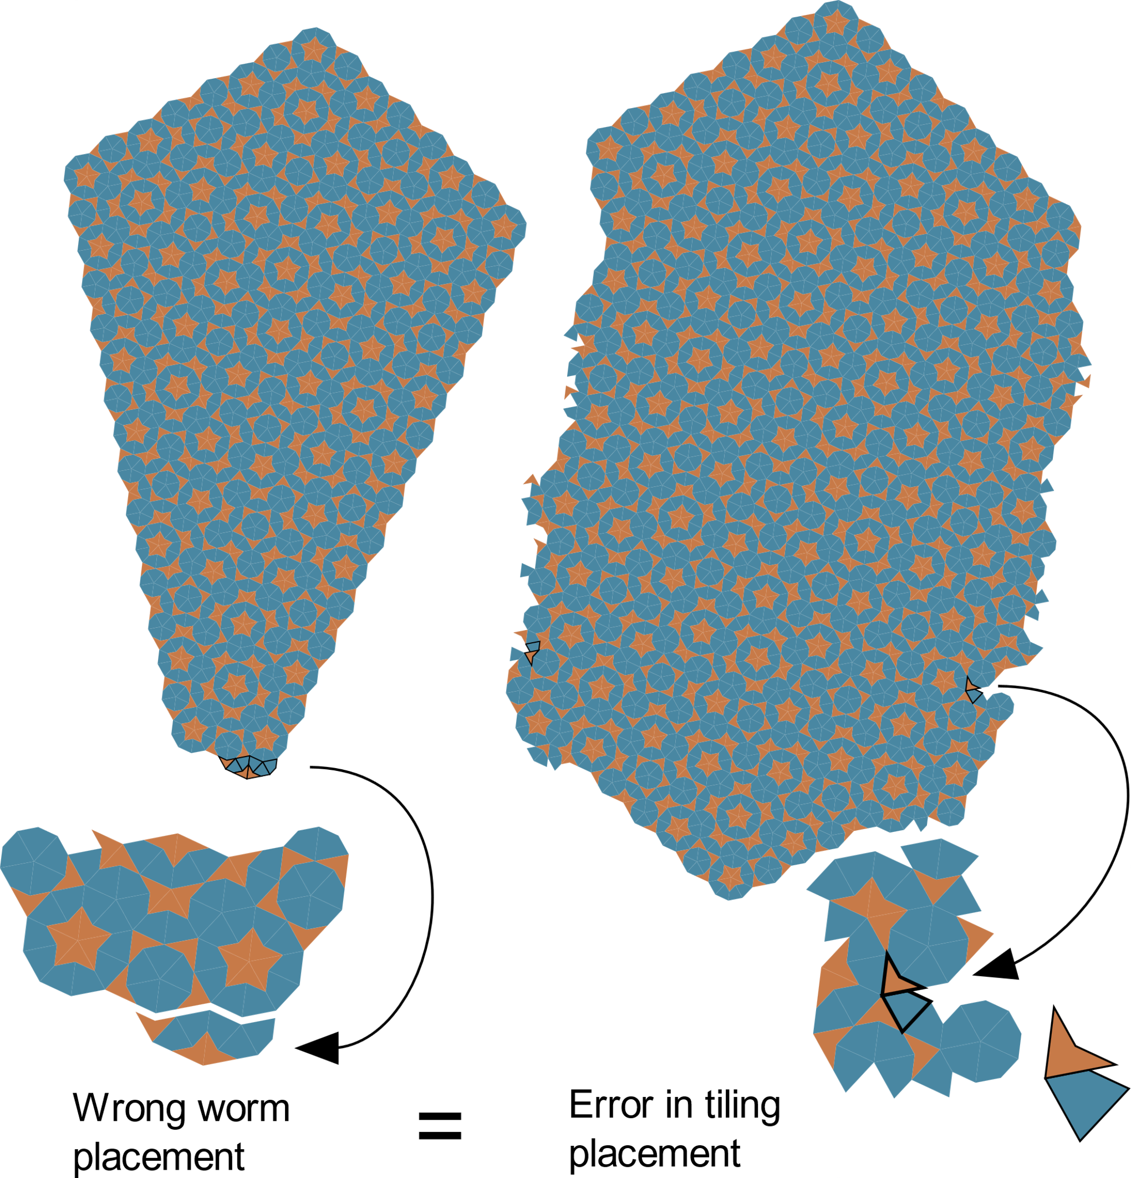

Figure 4

That’s it. Now, nothing’s left, just implement it to a programming language…for example in javascript.

Figure 5

**Program Implementation**

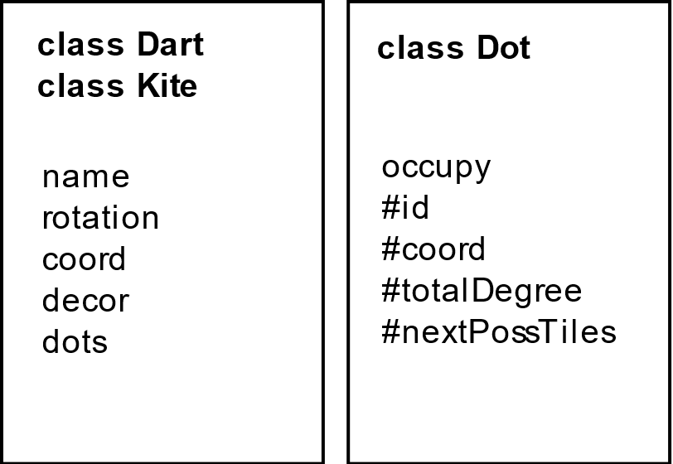**Kites, Darts** and **Dots** are classes to generate the objects and track the properties of them. Dots are collected in four Objects / Arrays by the **dotManager**:

* **allDots** – collection of all Dots
* **restrictedDots** – collection of restricted/forced dots
* **openDots** – collection of all Dots where can be attached a tile
* **inviewOpenDots** – collection of open dots, that are in the view area

// todo add to picture border permission

So on the first we generate a random tile with a random placement in the view area. For now we assume that is a Dart. We generate for this darts each pointa new **Dot**. Each Dot object tracks his occupation of tiles (**occupy**), and Tiles tracks his point occupation of **dots**. After that we look 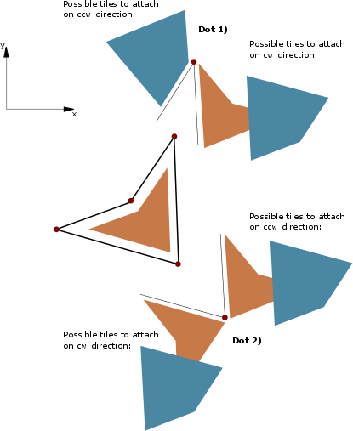for possibilities of each Dot of the Dart, what can be attached on the left and right sides or better said, on the clockwise (**cw**) and counterclockwise (**ccw**) direction.

This decides that the dot is a **restricted** or just **open.**

On the picture the Dot 1) would be a restricted dot, because of the one possibility on the ccw direction. On the other hand, the Dot 2) is just an open dot, which mean, we could randomly choose which one we want to attach. But stop, the first rule sais, that the restricted dots must be used up first!

After that, we can begin with the **mainLoop** till the Array of **restrictedDots** would be empty. So now we take the next restricted dot, Dot 1) and look on which side (cw / ccw) comes the forced tile, what tile (kite /dart) and with which point connects (A,B,C,D). Then we have a **blueprint** of the next tile (Kite, point C). We let then for the **tileManager** create the new Kite. The tileManager makes not too much, just create a new tile, rotate it and moves to the right position (gives just the right coordinates for the tile **coord** property).

Figure 6

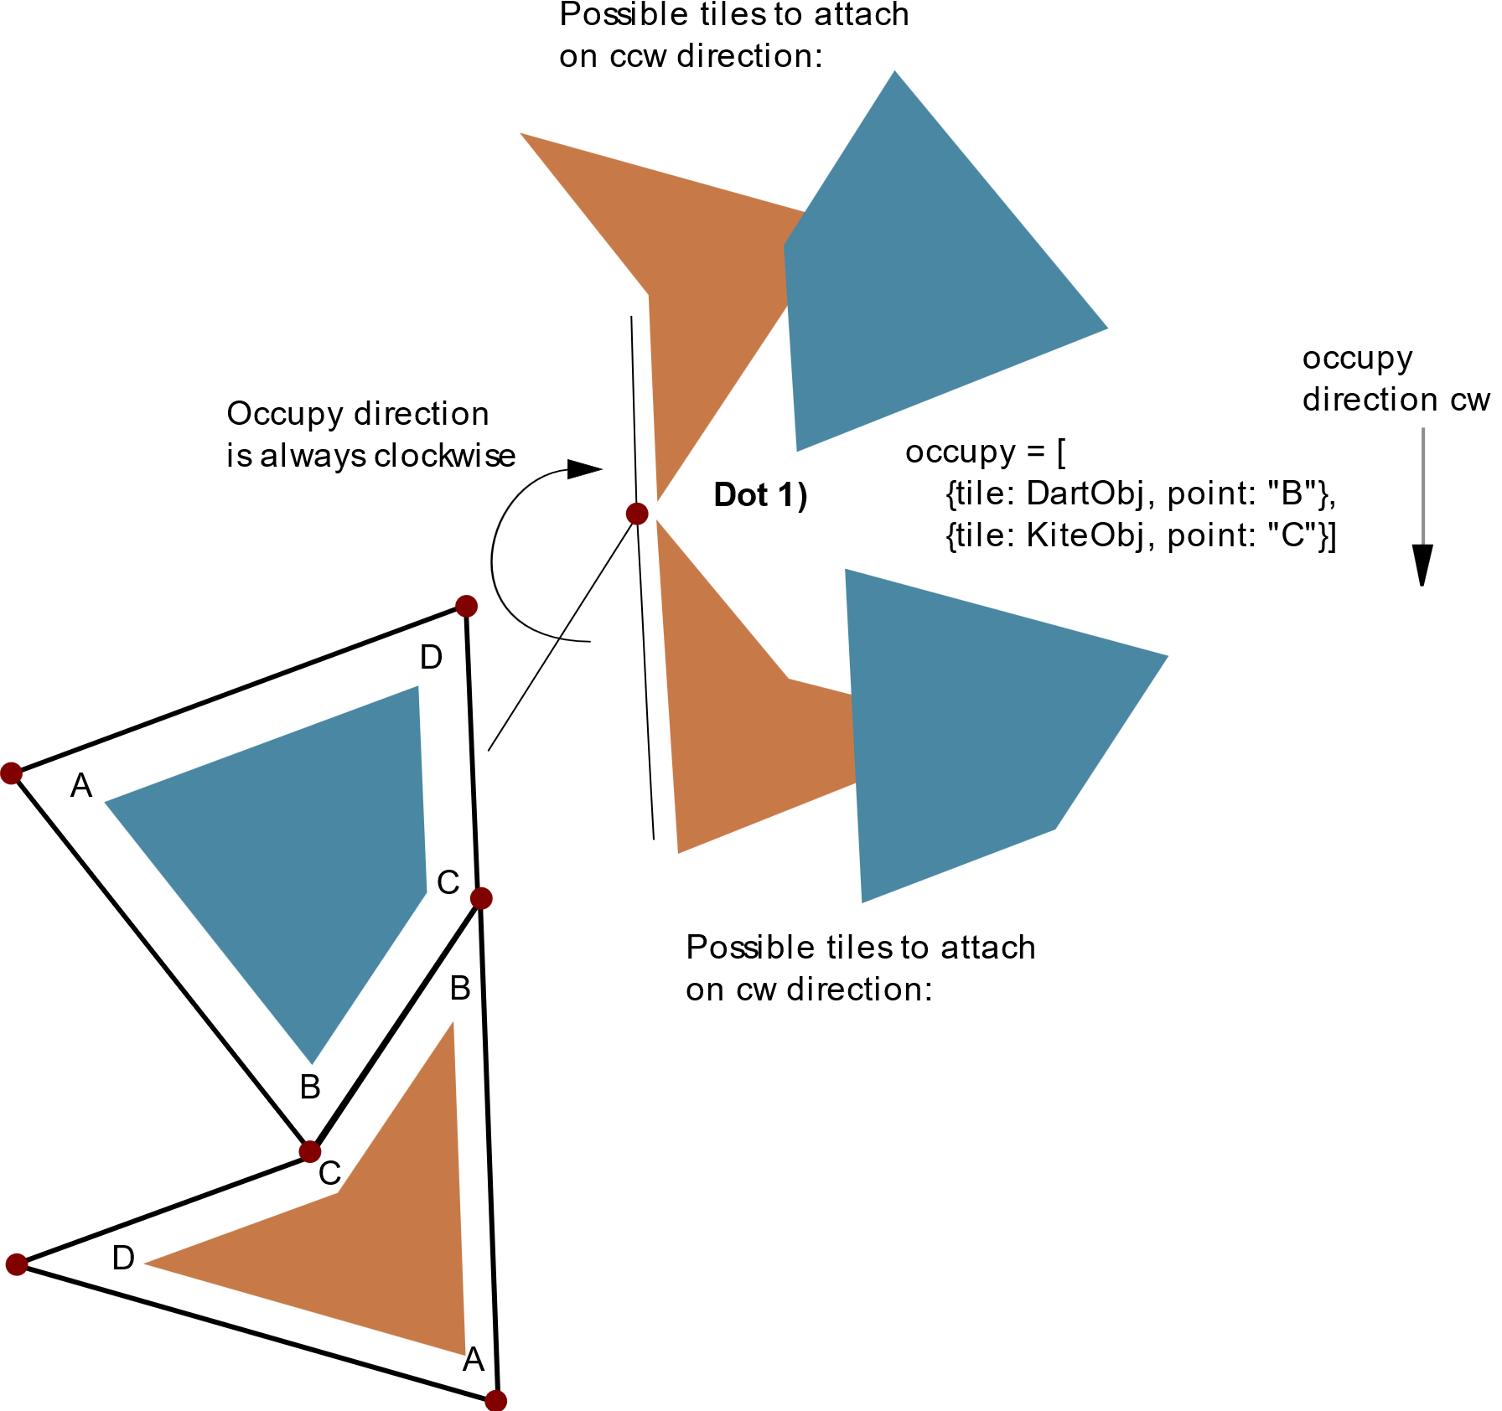Now we pass the new Kite to **dotManager** which like before, generates for each point a new Dot but first of all look for presents in the **allDots.** Then save the dot to the tile **dots** property and add the tile to the dot **occupy** property.

Here happens something important, that we look for the dot wether it is in the view field or not. If yes, we push it to **inviewOpenDots** too. The same happens with the tile. When its in the view field, we push it to **visibeTiles** (an Array in the model). We took the next restricted dot, and the whole loop goes around…

…till we reach a dead surface (a geomatrical shape) and no restricted dots are left. Now we choose randomly one dot from the **inviewOpenDots** Array and a random tile to place. That placement forces a new restricted dots. With that the whole process continue to place one tile after another.

Figure 7

When the invewOpenDots becomes empty, the whole loop stops and we become an SVG rendered on the screen from the **visibleTiles**.

That’s nice and easy. But when you ask what is with the second rule? When we randomly choose a dot on the short side of a coffin shape (on a green line from *Figure 2* )?

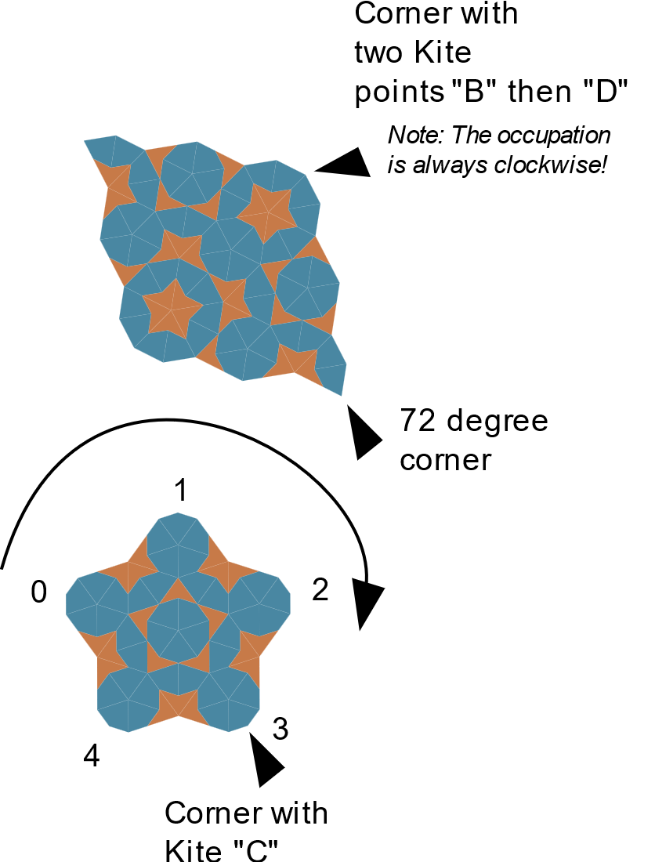

After we randomly choosed a dot, we must first look for the corners. The corner can be a dot with a single Kite tile with point “C”, with two Kites point “B” and “D” (in this sequence) or dot with **totalDegree** of 72. Just these three variations can be corners. (*Figure 8*)

After that, we have four or five corners. The number depends on the shape. (look back to *Figure 2.*). After we arrange the corners in a circular way, we can use the length of the sides and the number of cornes to decide which shape we have. (*for better understanding* *see Figure 8 and sourcecode – dotManager –> verticesRuleReferee()* ).

When its one of the coffin(like) shapes, then we look, that our random dot is one of the dots from the short side or not.

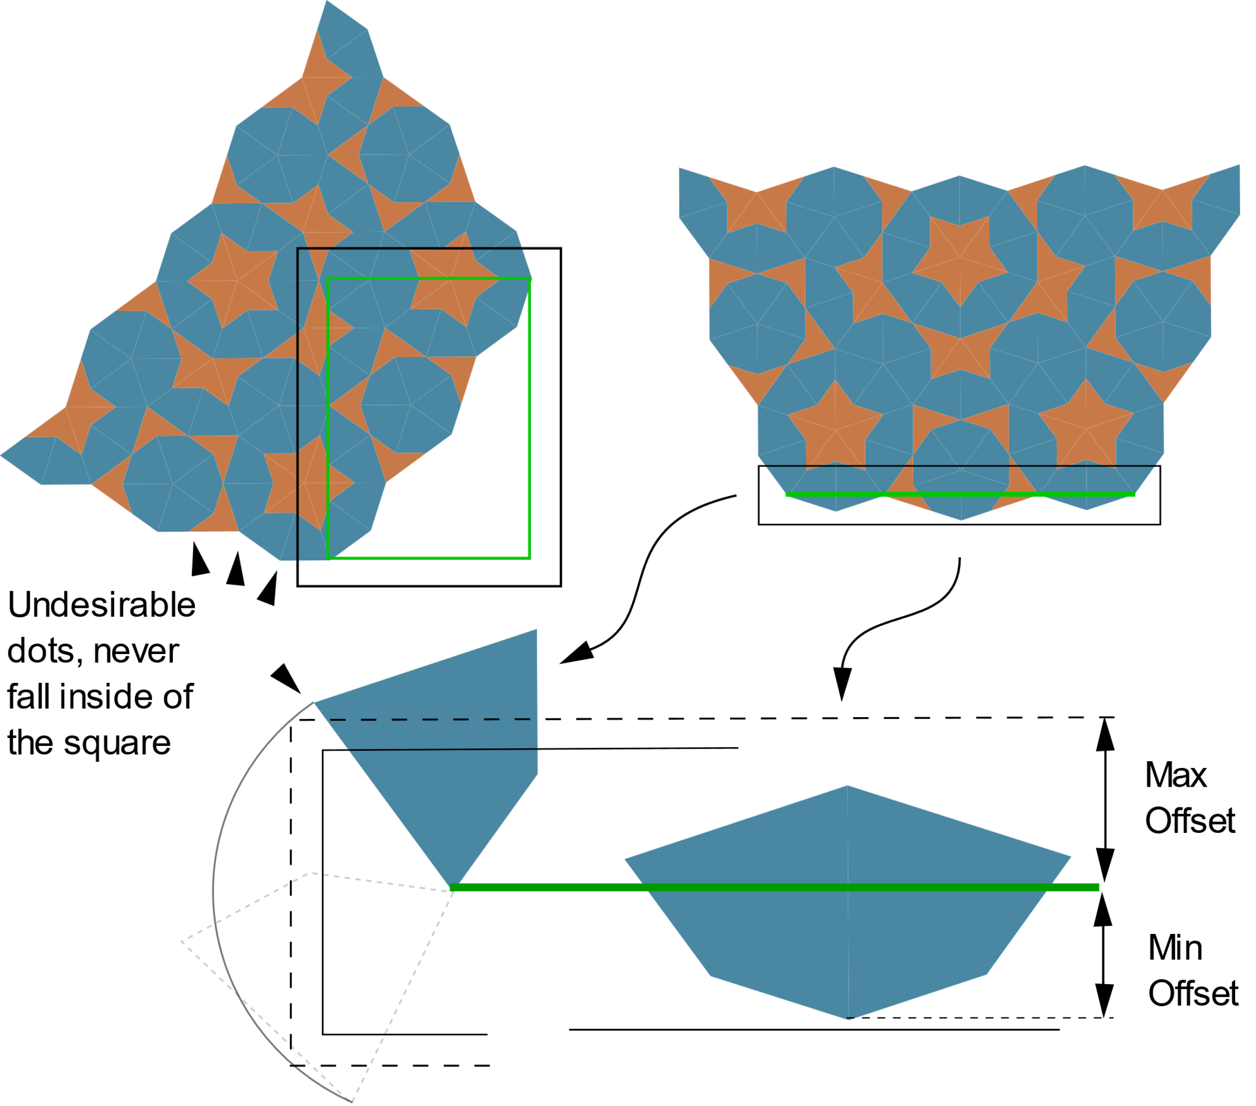

Figure 8

This happens as next in the function **checkDotPresenceOnShortSides**.

Imagine a square around the short side of the Coffin(like) shape. When the dot is inside the square, the dot lies on the short side. The square around the short side is outsized (offset) just so much, that undesirable dots from the neighbour sides never can fall inside of it, and every dot from short side is inside even when it lies horizontally or vertically. (*Figure 9*) When the dot lies on the short side, we need just to decide which tile must be placed for right worm placement.

Figure 9

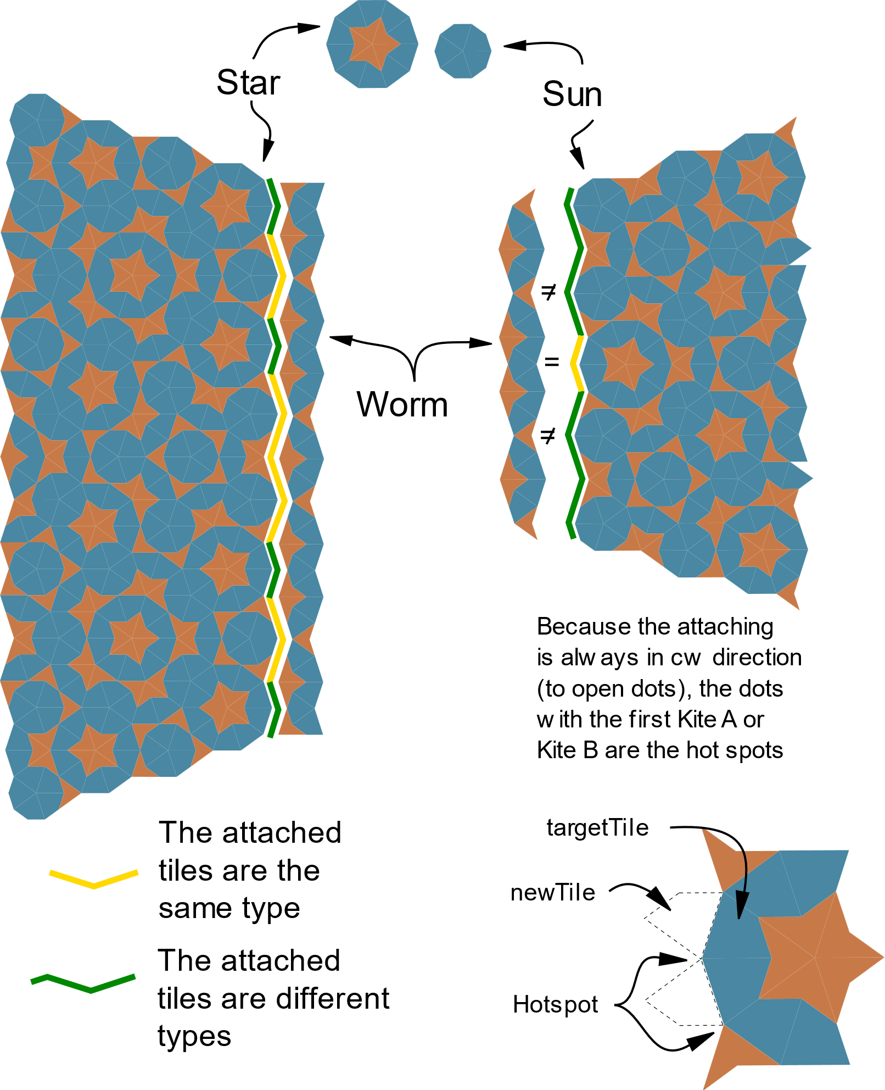On the first line, the corner formation, the “star” and the “sun” is important how the worm should be attached. On the second, you can see on the picture (*Figure 10*), there are always just two “hotspots” which we need beware of, the Kite “A” and “B” points. So, when the corner is sun then the **newTile** on the hotspot dots must be the same as **targetTile**. On other dots must be a different one. With the star on the corner is the opposite true.

This is the core logic. But I will show you some issues and solutions related with the code.

**Issues**

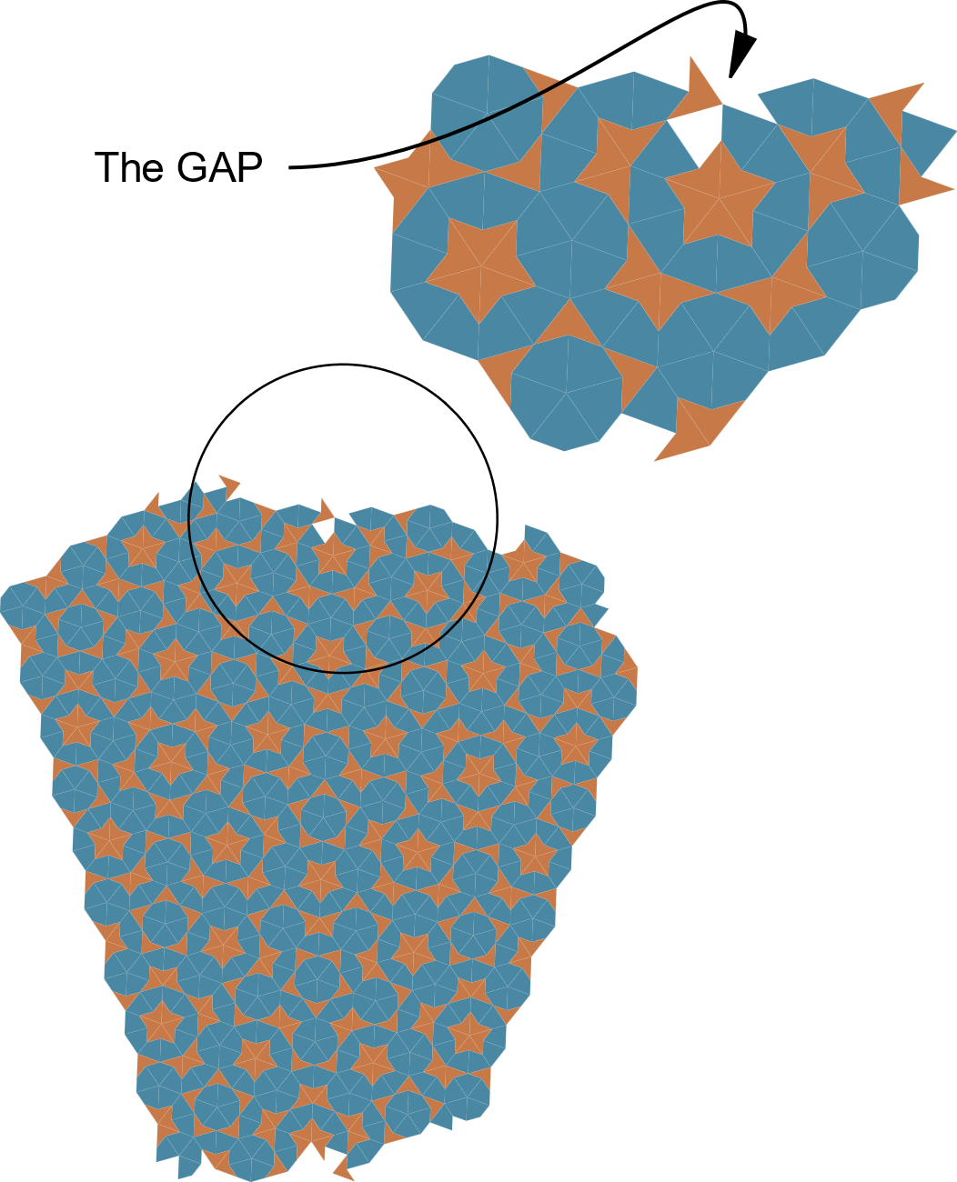The “GAP”

When you just look on the picture, you know what I mean. It can happen that a tile would placed so unluckily that no consistent edge would be formed, and one tile bridges over the other so, that an open tile spot arises. In that situation, when the **gapWatchdog** signals**,** we must remove the tile, undo everything related with the newly placed tile and move the **restrictedDot** (to which was the tile attached initially) to the end of the pile. /It happens, ca. 1 time out of 2000 generated tiles/

The “Corner cut”

How do we know, which tile should be rendered or not? Actulally it’s not a big brainer, when one dot of the tile is in the **Viewport**, then the whole Tile must be rendered. When no one is, the whole tile is outside and would be not rendered.

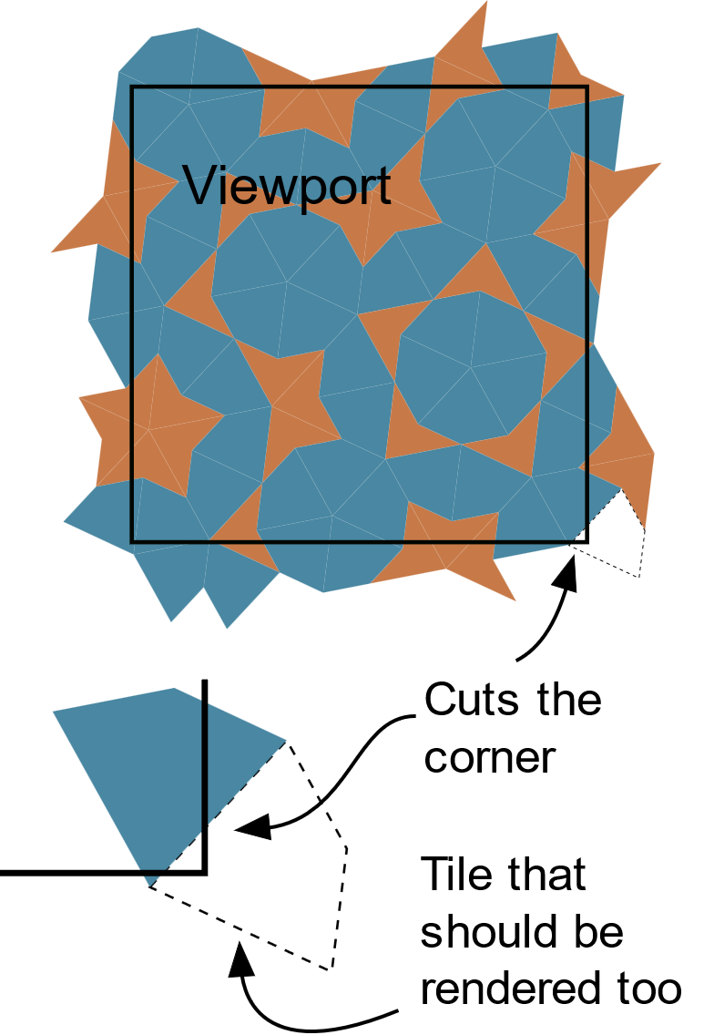But when two dots cuts the corner of the viewport, the Tile on the corner is not rendered too, despite it should be.

The thing is, I could go the lighter way and just render the tiles on an oversized viewport, but I wanted not pollute the DOM and the SVG (…and for the challenge too ;) ).

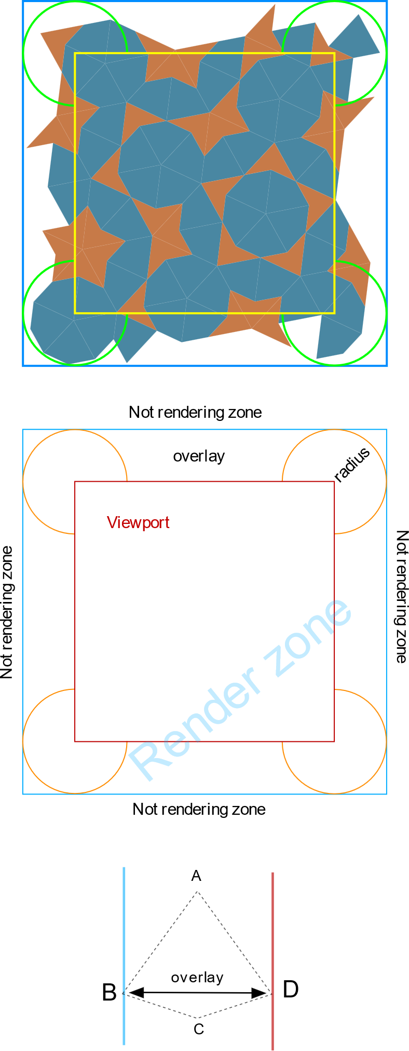

In the **borderControl** function we look where the dot is. It can be outside of the **renderZone** (then the tile is not rendered), in the **viewport** (the tile must be renderd), or in in the **overlay**. We don’t need render all in the ovelay, just those, which are at the corners, inside of overlay radius. The overlay radius is the two most distant point of a tile, which is the BD section. (see *Figure 13*, I hope it helps more to understand)

So each dot becomes an **borderPermission** with

* + - * + 1 – true -> the dot is inside of **viewport** (permission for rendering would granted of all tiles that is attached to it)
        + 0 – false -> the dot is outside of the **renderZone** (permisson would denied for all tiles that is attached to it)
        + -1 – week true -> the dot is inside of the radius (permission for rendering depends on and would be granted when **all** other dots of the tile have permission of -1 /or 1/ - in that case it mean, the whole tile is inside of the radius or reach inside of the viewport).
        + -2 – week false -> the dot is in the **overlay** but not in the radius (permission for rendering depends on and would be granted when minimum one dot of the tile have permission of 1, in other cases would be denied – when denied, it means, the whole tile lies partially or whole in the overlay and outside of radius, but not reaching inside the viewport).

So are all tiles rendered, which somehow reaches inside of the viewport.

**Decorations**

I set 2 decoration styles to add to the pattern, the **Amman** lines/bars or the **Arc**.

The Amman lines looks as next:

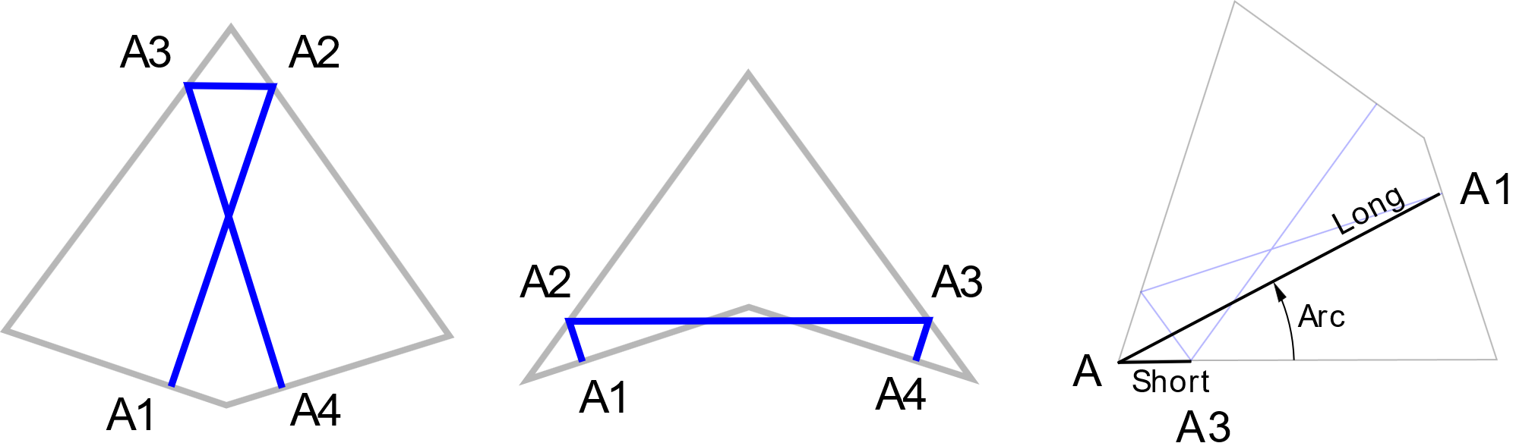

The Arc:

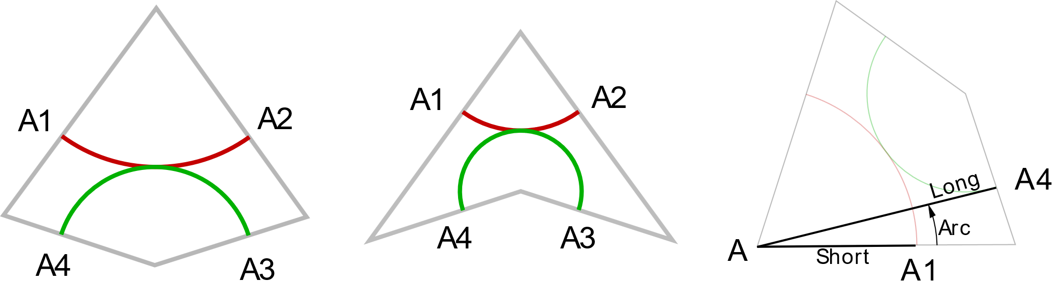

Every decoration point have its own coordinates, which is set in the A1 to A4 (A as Amman or Arc) in **decor** property of the tile. I have hardcoded the **short**, **long** and **arc** in the tile prototype (for not JS coders, prototype is a JS term), whitch are needed for calculating the coordinates of the decoration points (see source code). The decor property is then needed next when we generate the polygons for the svg in **renderView** module. For more about decoration please read:

* Amman lines/bars <https://ksuweb.kennesaw.edu/~sedwar77/tile/aperiodic/empires/ammanbars.htm>
* Arc

<https://mathworld.wolfram.com/PenroseTiles.html>

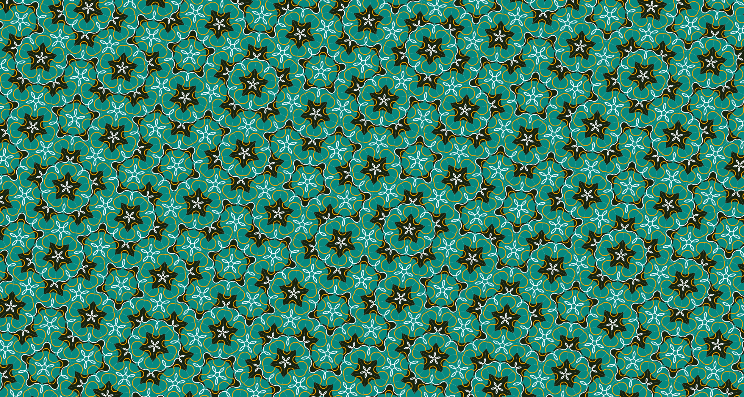Tip: When you know a little in svg, then you can play around in source code with the arc decoration path and you can get some interesting, “nonstandard” patterns like this:

**Appendix**

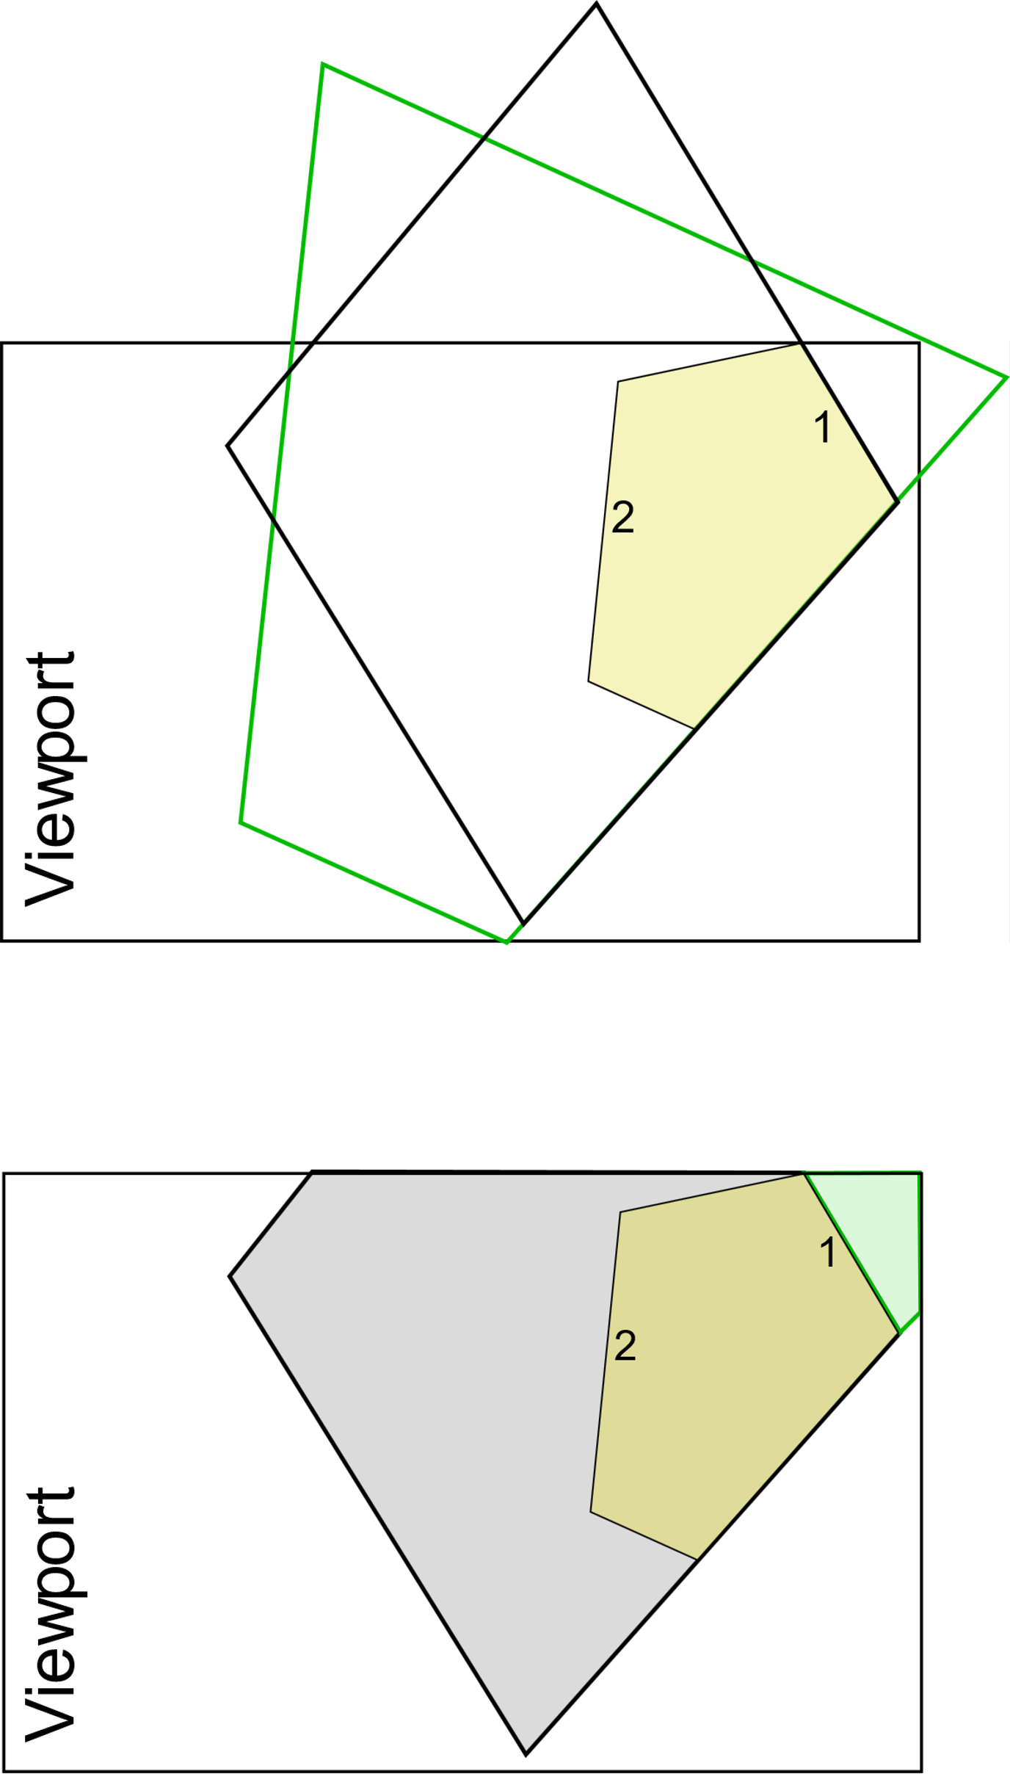And as last thing you can ask is, when we generate tiles till to dead surface, then many of them would lie outside of the viewport and would be not rendered, then why we generate them at all? So, yes many of them or most of them would be not rendered, but when we don’t do it, then it can be, that our pattern wouldn’t be accurate. The growing shape sometimes overgrows the starting shape from more or each side. This mean, it is common, that the tiles on one side depends from the growth of the other side and when we stop the growth because there is the viewport border, and then generate an other constellation to the side where should be tiles already (but because we stopped the growth, there are no tiles), we become an unaccurate pattern, which don’t exists on the whole infinite penrose world…

Example:

(top) When we continue growing on the side ’1’ of the coffin, assume we become the green line shape.Then the side ’2’ would be occupied i.e. in this example the side ’2’ depends on growth on side ’1’. But when we grow on the side ’2’ and not ’1’, become the shape black.

(bottom) When we would stop with the grow because of the border of vewport, and we generate the same tile on side ’1’ and side ’2’ like previously, then it happens that, what souldn’t be happening… an unaccurate pattern.

I hope it helps the logic better to understand and pick-up faster the source code.

Please let me know when you have questions,issues or something related with the project.

Thank you for reading,

Regards

Peter Duricek